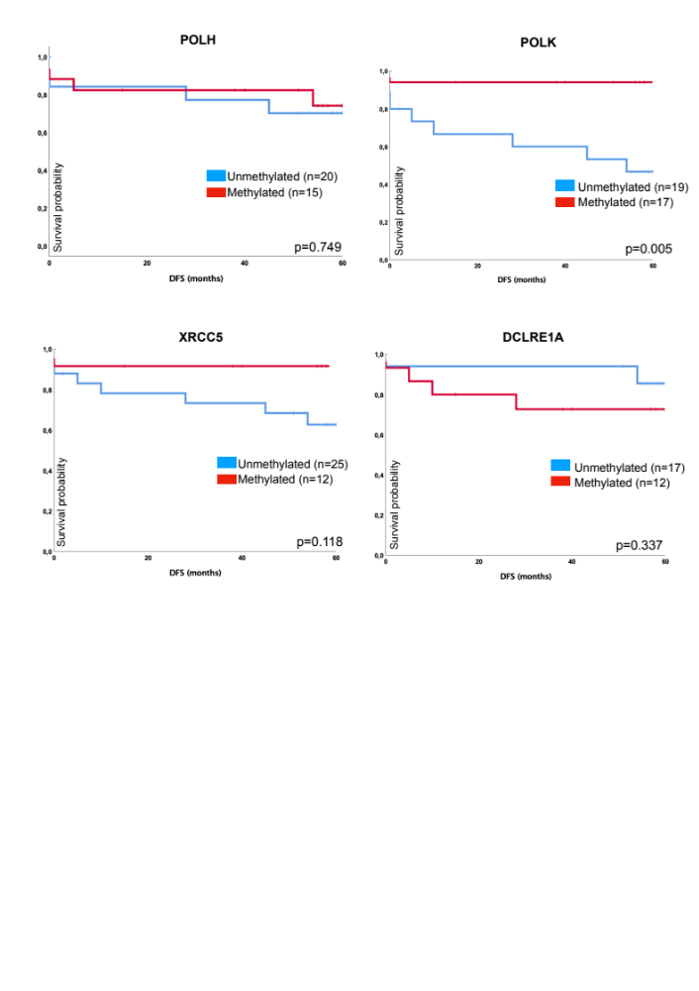
Supplementary Figure S4: Associations of disease free survival of DNA repair gene methylation of POLH, POLK, XRCC5 and DCRLE1A utilizing Kaplan-Meier curve.

